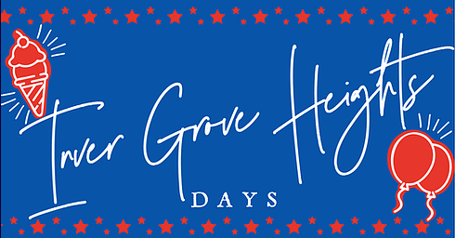
P.O. Box 2031 Inver Grove Heights, MN 55076

Dear Friends,

Summer is here and so will thoughts of community festivals and parades!

2023 Inver Grove Heights Days will be held September 6th thru 10th, and we would like you to be part of our city celebration.

The 27th Annual Inver Grove Heights Days Parade will take place Saturday, September 9th.

Enclosed is a parade unit entry form, a liability waiver release and required proof of insurance information. Return completed forms and a check for the entrance fee by July 31, 2023. Incomplete forms and/or unpaid entrance fees will not be processed. Please be sure to include all required forms and a contact email address.

We love to see new units enter each year and if you participated in years past, we hope you will join us again this year!

Additional parade line up information and your unit line up number will be posted to www.invergroveheightsdays.org by Labor Day. The parade will begin at 11am, sharp, with line-up starting a 9:30am. Parade guidelines are on the backside of this letter.

If you have any questions the Parade Director can be reached by email rrreitberger@yahoo.com

We look forward to your participation in the 2022 Inver Grove Heights Days Parade!

Sincerely,
Robin Reitberger
Inver Grove Heights Days, Parade Director

INVER GROVE HEIGHTS DAYS
PARADE LIABILITY WAIVER AND AGREEMENT

I the undersigned have agreed for our own benefit to participate in the Inver Grove Heights Days Parade connected with and under the direction of Star City Days, Inc.

I understand that inherent in our participation is the risk of serious personal injury and property damage. I/we understand that the Inver Grove Heights Days Parade will not provide us with protection against injury and damage, and I assume all risk of such injury and damage to myself and others under my direction and control, and to my property and all other property under my direction and control.

I hereby waive and release any claim we have and may have in the future against Inver Grove Heights Days, Star City Days, Inc. and its volunteers, partner, and principals. Furthermore, I release any claim for any other damage that I might sustain, whether caused in whole or in part by the negligence of such officers, directors, agents, partners, principals, and volunteers, which occurs during or because of our participation in the Inver Grove Heights Days Parade.

Furthermore, I represent that myself or anyone operating a vehicle in the Inver Grove Heights Days Parade or in conjunction with the event has a valid license to drive such a vehicle and has appropriate vehicle and liability insurance.

I agree that there will be no use of Alcohol, Fireworks, Explosives, or any other items that may be considered illegal, or inappropriate for a public event. Furthermore, we understand that the Inver Grove Heights Days parade director and his/her representatives are the final authority in decisions of appropriateness, and we agreed to abide by her/his decisions.

I understand that parade route and line up information will be sent to us approximately 5 days prior to the event. I understand that if we arrive for line up late we may lose our place in the lineup and be placed in the parade line up at the parade director’s discretion or not at all.

I furthermore agree to obey and abide by the rules set forth by the parade director, parade committee, Inver Grove Heights Days Committee and Star City Days, Inc. and any direction given, by the Inver Grove Heights Days Parade Director or Inver Grove Heights Committee Members and volunteers, including but not limited to, abstaining from throwing candy or other items from parade units and the laws regarding consumption of alcohol by drivers, passengers, or unit participants during line up, on the parade unit, along the parade route or at the end of the parade.

NAME OF UNIT: _______________________________________________________________________________________
SIGNATURE: ___________________________________________________________ DATE: _______________________
NAME (PLEASE PRINT): _______________________________________________________________________________
INVER GROVE HEIGHTS DAYS
PARADE UNIT INSURANCE DECLARATION

I the undersigned declare that the insurance information listed below is true. I further declare that the policy listed below with be in force on the date of the event.

Unit insured by: _ Policy Number: ____________________

(Insurance Certificate must be attached with Star City Days, Inc. named as additional insured.)

